DDFC (Pvt.) Ltd.

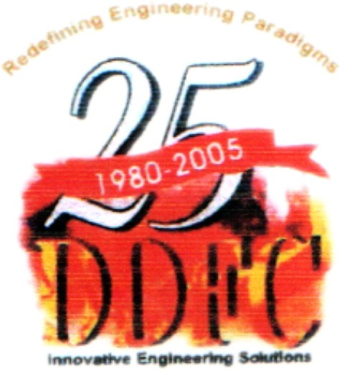

Engineering Works

**27-KM, Multan Road, Lahore, Pakistan**

**Ph: +92 (042) 7541361 to 63, Fax: +92 (042) 7541364**

**UAN: 111-333-233, E-mail: ddfc.northbd@ddfcgroup.com**

**ISO 9001 : 2000 Certified ASME “S” & “U” Stamps Certified**

**TO WHOM IT MAY CONCERN**

It is certified that Mr. <Name> S/O <fname> has been working in this organization as “<Designation>” intermittently and purely on temporary basis from <From> to <To>.

During his work with us we found him very hard working, honest and trustworthily and wish him best of luck in his future assignments.

**For DDFC (Pvt) Ltd.**



**Incharge Administration**

**DDFC Group of Companies**

**FLOWTRONIX (Pvt.) Ltd.**

**Engineering kinetics (pvt.) ltd.**

**DDFC (Pvt.) Ltd.**

**Head Office: 73-G/II, Model Town, Lahore 54700, Pakistan. UAN: 111-355-355**

**Tel: +92 (042) 5885727 to 32, Fax: +92 (042) 5885733 E-mail: ddfc.mktg@ddfcgroup.com**

**South Office:**

1. **D/1, 1st Gizri Lane, Defence Housing Authority, Phase IV, Karachi, Pakistan.**

**UAN: 111-355-355, Tel: +92 (021) 5870289, Fax: +92 (021) 5836870 E-mail: ddfc.southbd@ddfcgroup.com**